Performing Arts Department

Mrs. Sophia Rolle-Joseph
Head of Department

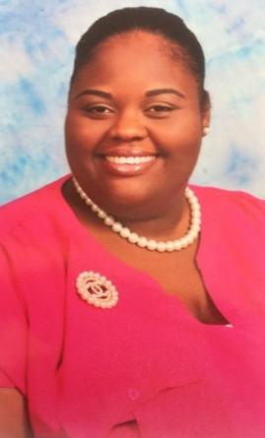
Ms. Crashan Johnson
Choir Director

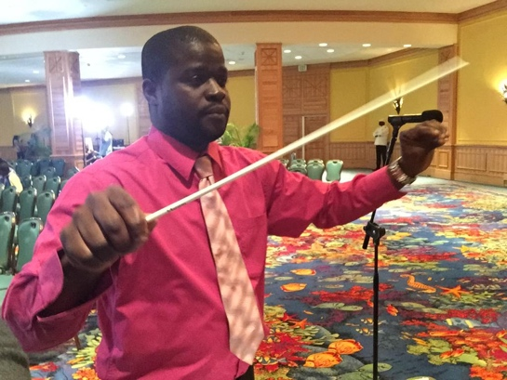
Mr.Marvin Sands
Band Director

Ms. Deresa McPhee
Dance Teacher

Department Supply list
-Elements of Music Instrument book (book designated for personal instrument)
-Personal Instrument
-Music Theory in Practice (based on teacher’s grade level decision)
-Manuscript book

