C.R. WALKER SENIOR HIGH
FAMILY AND CONSUMER SCIENCE EDUCATION

Department Members

Mrs. E. Russell -Subject Co-Ordinator Family and Consumer Science

Mrs. M. Roberts-Brown – Family and Consumer Science

Mrs. J. Grant - Cosmetology

Mrs. M. Meadas – Family and Consumer Science

Family and Consumer Science Events and Accomplishments

Departmental Day 2020

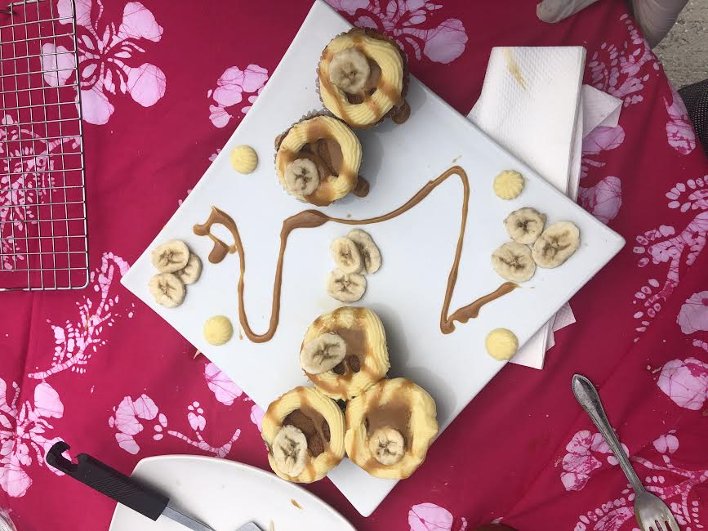
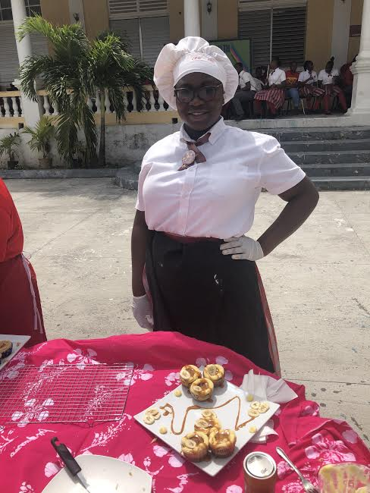

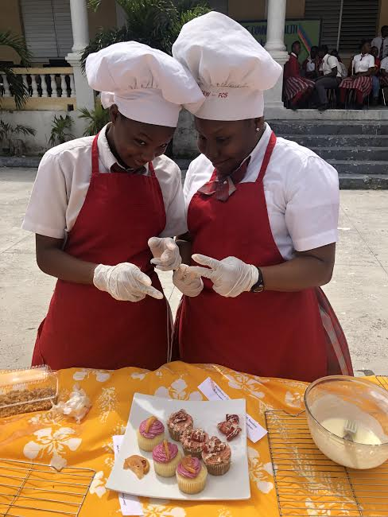

Beauty Trades Workshop with Mrs. Italia Wilson

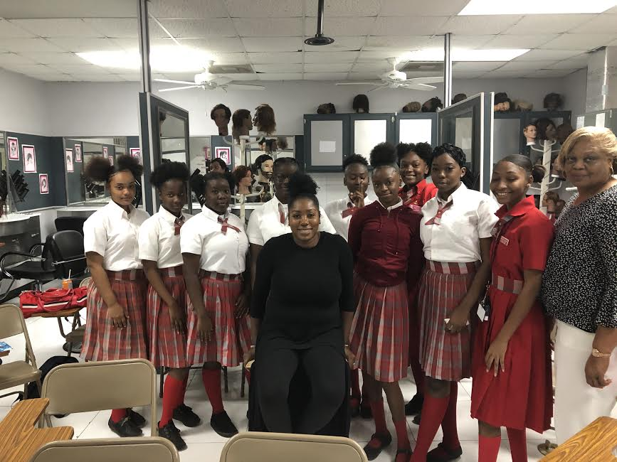

CTE EXHIBITION 2018

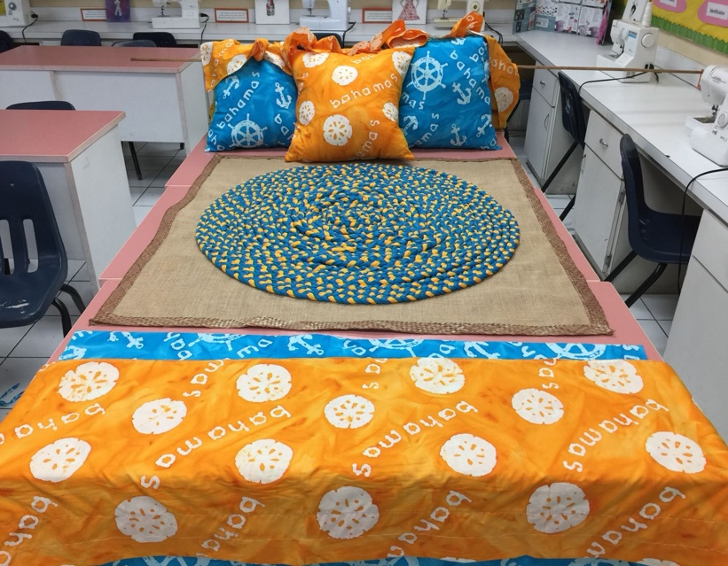

Young Chef Competitions

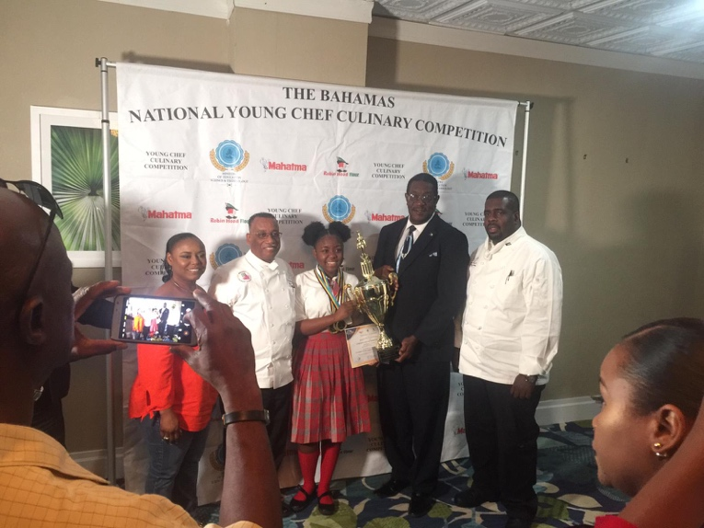

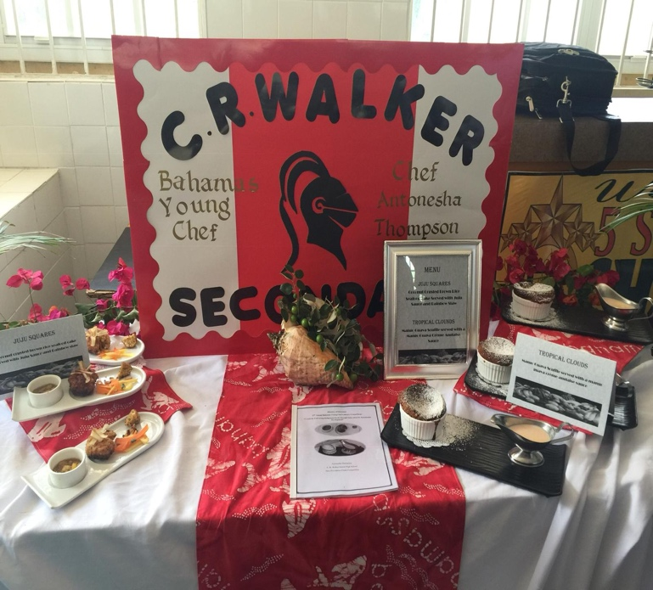
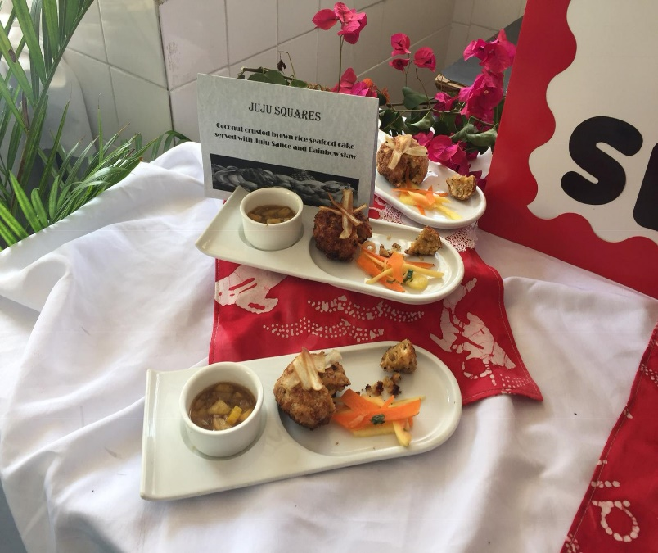

FAMILY AND CONSUMER SCIENCE
BOOKLIST, RESOURCES AND MATERIALS
2020-2021

Food and Nutrition Book List Grade 10-12

- Food and Nutrition by Anita Tull
FOOD AND NUTRITION: School Edition Paperback – January 23, 1997
- ISBN-10 : 0198327668
- ISBN-13 : 978-0198327660

*Supply List will be given two weeks before any demonstrations or practical is conducted.

Clothing and Construction Book and Supply List Grade 10-12

Clothing: Fashion, Fabrics & Construction, Student Edition (CLOTHING: FASHION,FABR & CNSTR)
by Jeanette Weber (Author)
- ISBN-10 : 0078767954
- ISBN-13 : 978-0078767951

Clothing and Construction Standard Resources needed Grade 10-11:
1 ½ yard of fabric
1 Matching thread
Assorted hand needles
Embroidery needle
5-10 embroidery floss (assorted colors)

Cosmetology Books and Resources need:
GRADE 10
Materials

- One Mannequin Head /With Stand
- Rollers
- Roller Clips
- Spray bottle
- 4 Towels
- 8 or 10 pc comb set
- 1 Bristle Hair Brush
- Shampoo
- Conditioner
- 1 Shampoo Cape
- 2 Towels
- Pin Curl Clips
- Lotterbody/gel
- Spray bottle
- 1can sheen spray
- 1spritz
- 1 Gel
- Bobby Pins
- Hair Pins
- 1 Conventional Thermal Stove
- 2 Conventional Thermal Iron
GRADE 11
Materials

- One Mannequin Head /With Stand
- Cholesterol Conditioning Cream
- 4 Towels
- 1Shampoo Cape
- 1 Styling Cape
- 1 Rattail Comb
- 1 Applicator Brush
- 1 Applicator bowl
- 1 Conventional Thermal Stove
- 2 Conventional Thermal Iron
- 1can sheen spray
- 1spritz
- 1 Gel
- Bobby Pins
- Hair Pins
- 1 Pk Duckbill Clips
- 1Pk Weave
- 1Pk Synthetic Hair

MANICURE MATERIALS
- Instant Dry Enamel
- Nail Polish Remover
- Toe Nail & Fingernail Clipper
- Cuticle Nipper
- Cuticle Pusher
- Cuticle Oil
- .Orangewood Sticks
- Top Coat & Base Coat
- Foot File –Nail File
- Tweezers
- Nail Bush
- Buffer -1Black -1White
- Manicure Bowl
- Pedicure Tub

GRADE 12
Materials

- One Mannequin Head /With Stand
- 12 pks of permanent wave rods
- 4 Towels
- 1Shampoo Cape
- 1 Styling Cape
- 1 Rattail Comb
- Bobby pins/ Hair pins
- Gel
- Spritz
- I pk weave
- Gloves
- Cutting Shear
- Spray bottle
- Haircutting comb
- Color kit
- Bw2
- Developer
- Adore Color Rinse
- Streaking caps/foil paper
Facials
- Cleansing cream
- Moisturizer
- Toner
- Exfoliant
- Mask
- Facial pads
- Makeup remover

